Many employees find that they want to view their financial records and print check stubs for various reasons. At Paychex Flex, you can access your financial data any time from any computer. Just follow the instructions below:

To Register with Paychex and view your paystubs, go to:

<https://myapps.paychex.com/landing_remote/html>

You will come to a screen this screen.

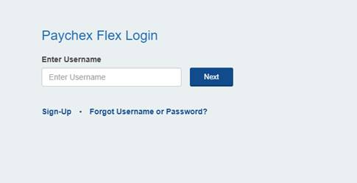

If you are a first time user, click **Sign-Up** and follow the instructions to register.

Then save your user name and password for future use.

Once registered, you will be free to visit the site any time to view and print pay stubs.

If you have already set up an account, enter your user name and follow instructions.

**NOTE:**  This site is best when viewed on a desktop or laptop computer.  Trying to access it on your phone or tablet will be difficult.  Also, you will likely get best results using Google Chrome as your web browser.

If you need extra help registering, click the link below for instructions:

<https://cdn.paychexinc.com/ent/png/loginLite_static/201711081051/help/log_in/logging_in.html>

Paychex also has a smartphone app you can download at Google Play Store for free.

Since Paychex is a separate company, customer service concerns for their services and using their site should be directed to their Customer Service Office using the “Contact Us” link on their site or call 888-246-7500.